RESIDENTIAL POOL BARRIER REQUIREMENTS

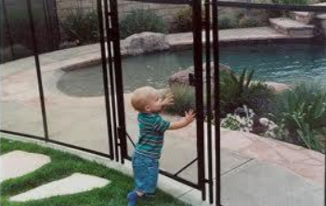
Residential Swimming Pool:
Any structure intended for swimming or recreational bathing that contains water more than 48” deep. This includes in-ground, above ground and on-ground swimming pools, hot tubs and spas.

Barrier:
A fence, wall, building wall or combination thereof which completely surrounds the swimming pool and obstructs access to the swimming pool.
All outdoor swimming pools shall have a barrier which complies with the following:
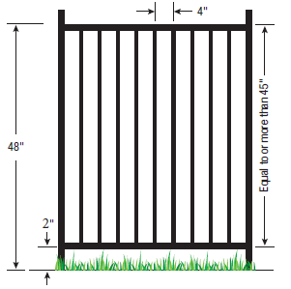
- The top of the barrier must be at least 48 inches above the surface measured on the side of the barrier which faces away from the swimming pool.
- The maximum vertical clearance between grade and the bottom of the barrier shall not exceed 2 inches for grade surfaces that are not solid (grass, gravel) measured on the side of the barrier which faces away from the swimming pool.
- The maximum vertical clearance between the surface below the barrier to a solid surface (concrete) shall not exceed 4 inches measured on the side of the barrier that faces away from the swimming pool.
- Openings in the barrier shall not allow passage of a 4-inch diameter sphere.
- Where the barrier is composed of horizontal and vertical members and the distance between the bottom and top horizontal members is less than 45 inches, the horizontal members shall be located on the swimming pool side of the fence.
- Where there are decorative cutouts, spacing within the cutouts shall not exceed 1¾ inches in width.
- Where the top of the pool structure is above grade or surface, such as an above ground pool, the barrier may be at ground level, such as the pool structure, or mounted on top of the pool structure. Where the barrier is mounted on top of the pool structure, the maximum vertical clearance between the top of the pool structure and the bottom of the barrier shall be 4 inches.
- Solid barriers, which do not have openings, such as a masonry or stone wall, shall not contain indentations or protrusions except for normal construction tolerances and tooled masonry joints.
- Maximum mesh size for chain link fences shall not exceed 1¼ inch square unless the fence is provided with slats fastened at the top or the bottom which reduce the openings to no more than 1¾ inches.
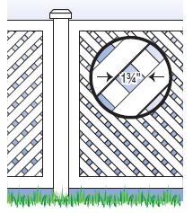
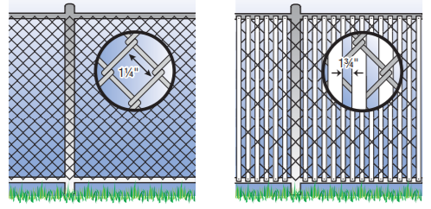
- Where the barrier is composed of diagonal members, such as a lattice fence, the maximum opening formed by the diagonal members shall be no more than 1¾ inches.
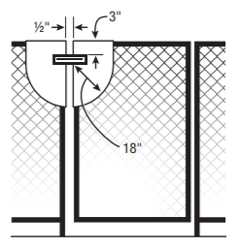
- Access gates to the pool shall be equipped with a locking device. Pedestrian access gates shall open outward, away from the pool, and shall be self-closing and have a self-latching device. Gates other than pedestrian access gates shall have a self-latching device. Where the release mechanism of the self-latching device is located less than 54 inches from the bottom of the gate, (a) the release mechanism must be located on the pool side of the gate at least 3 inches below the top of the gate and (b) the gate and barrier must have no opening greater than ½ inch within 18 inches of the release mechanism.
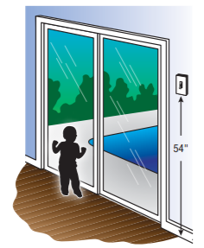
- Where a wall of a dwelling or structure serves as part of the barrier and where doors or windows provide direct access to the pool or spa through that wall, one of the following shall apply: (a) the pool shall be equipped with a powered safety cover in compliance with ASTM F1346. (b) Operable windows having a sill height of less than 48 inches above the indoor finished floor and doors with direct access to the pool through that wall shall be equipped with an alarm which produces an audible warning when the door and/or its screen, if present, are opened. The alarm shall be listed and labeled in accordance with UL 2017. The deactivation switch(es) shall be located at least 54 inches above the threshold of the door (c) Other means of protection, such as self-closing doors with self-latching devices, are acceptable so long as the degree of protection afforded is not less than the protection afforded by (a) or (b) described above.
- Where an above ground pool structure is used as a barrier or where the barrier is mounted on top of the pool structure, and the means of access is a ladder or steps, then (a) the ladder to the pool or steps shall be capable of being secured, locked or removed to prevent access, or (b) the ladder or steps shall be surrounded by a barrier. When the ladder or steps are secured, locked, or removed, any opening created shall not allow the passage of a 4 inch diameter sphere.
- Spas or hot tubs with a lockable safety cover and swimming pools with a powered safety cover that complies with ASTM F1346 shall be exempt.

